Richard Benfer
Position: Teacher
Local Association: TAAAC

Jennifer Bezy
Position: Teacher
Local Association: HCEA(Howard)

Hello! My name is Jennifer Bezy. I am currently serving as a member of HCEA's Board of Directors. I've worked with our community to unseat our past Superintendent and appoint one that has the children and the community in his best interests. I would be honored to represent HCEA at the NEA RA. Thank you!

Betsy Brininger
Position: Teacher
Local Association: TAAAC

TAAAC BOD, NEA delegate 2008-2019, MSEA delegate 2008-20019; PAC captain for Anne Arundel County at state and national conventions.

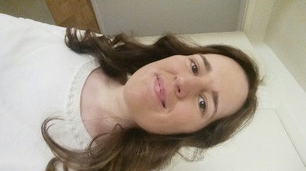

Emmanuelle Carr
Position: Teacher
Local Association: TAAAC

Bonjour, as a French native speaker teaching at Glen Burnie High and member of the TAAAC Board of Directors, I passionately fight for our students, members, schools and communities. I served as a delegate at both 2019 NEA and MSEA RA’s and look forward to being your voice again. Please vote for me. Merci!

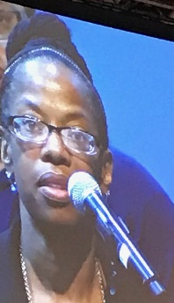

Leirdre' Clements Galloway
Position: Teacher
Local Association: HCEA(Howard)

Please Stay with L. Galloway..Allow me to continue working with and for YOU!
Red for Education is not just a chant! Let my passion, focus, energy and positive attitude work promoting, informing, supporting and motivating. I’ve represented at NEA Convention, & Leadership Summit, worked with members on different capacities including Membership, Elections, MAC and Negotiations.

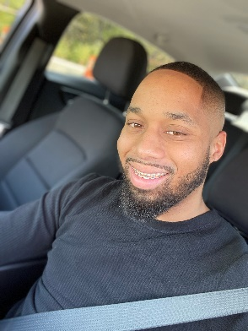

Keion Dorsey
Position: ESP
Local Association: SAAAAC

Vice President of Local SAAAAC, NEA Delegate RA 2018, 2017, MSEA Delegate RA 2015-2018. As an ESP delegate I will be supporting the healthy growth and development of all ESP's by using my voice in fighting for our cause.

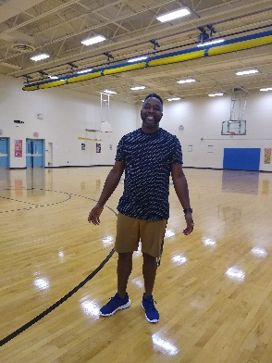

Jason Fahie
Position: Teacher
Local Association: HCEA(Howard)

My name is Jason Fahie and I would like to continue my activism, by representing you, the members, as a delegate to the 2020 NEA Representative Assembly in Atlanta. Delegates need to be dedicated, focused, and informed and I believe I embody these qualities. I appreciate your support and thank you for your time.

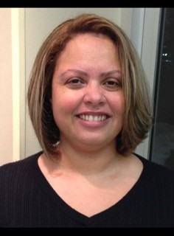

Anna Gannon
Position: Teacher
Local Association: HCEA(Howard)

It is my desire to represent you in the upcoming year for the issues that are most important to our members. I pledge to make decisions on your behalf that maintain the spirit and intent of our member’s organizational values. Please vote Anna Gannon as Delegate!

Sarai Gray
Position: Teacher
Local Association: HCEA(Howard)

I am currently the HCEA Secretary, have been an MSEA delegate for six years and would be honored to represent HCEA and all special area educators at the NEA for a fourth year. I hope you can support me.

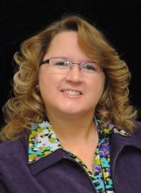

Lauri Hornicek
Position: Teacher
Local Association: HCEA(Howard)

I would like to represent MSEA at the NEA convention. I will listen, learn, and voice an opinion on important issues when needed. I will ask questions and seek out answers to share with members. I will be an involved member at our convention. Thank you for considering.

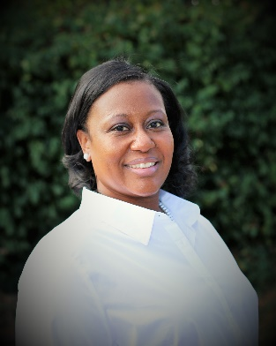

Keishanna Hunt Brown
Position: Teacher
Local Association: HCEA(Howard)

I am a special educator of 14 years. I worked as a FAC Chair, MSEA, NEA Delegates and on the MAC in Prince George’s County Public schools. I am a diligent advocate for colleagues and student success in public education. Allow me the opportunity to be your spokesperson to continually advocate for teachers and students.

Hugo Jackson
Position: Teacher
Local Association: HCEA(Howard)

Help me to help you and our state at the NEA Convention. Vote Hugo in. Experience as a mentor, Special Educator, Union rep and Coach.

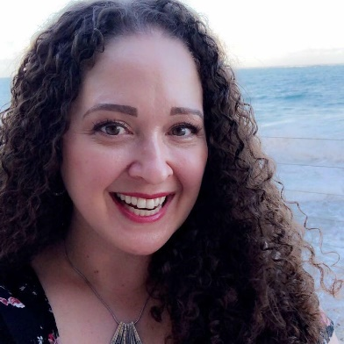

Danielle King
Position: Teacher
Local Association: HCEA(Howard)

I would like to represent all educators again, at the National level, at the NEA convention this summer!

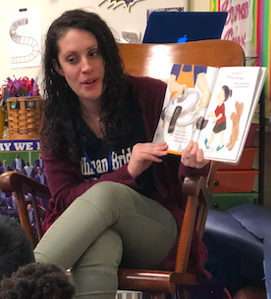

Rachel Lewis
Position: Teacher
Local Association: HCEA(Howard)

I’m a Reading Specialist who believes in creating equitable learning environments that values every teacher, student and parent as part of the learning community. As an association representative, I plan to use my expertise in reading, behavior, special education and public policy to further this mission. Change will happen when we work together.

Kathleen MacLaughlin
Position: Teacher
Local Association: HCEA(Howard)

For years, I’ve advocated for the members in my building, local and community. I want to be an advocate for my state at the NEA convention. The united force of thousands of educators means real change for our organization. I want to be an active part of that process. Thank you!

Georgianne McNeirney
Position: Teacher
Local Association: HCEA(Howard)

With 25 years as member of NEA and MSEA I have the perspective of speaking for our members and the students whom we teach. I am open to listening and voting for what benefits us as a whole inclusive group. I look forward to being part of the future of our educational system.

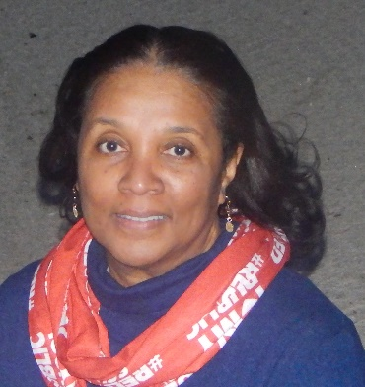

Reba Miller
Position: Teacher
Local Association: TAAAC

Hi, my name is Reba Miller and I am seeking your vote to attend the NEA conference as a delegate. I have served as a local building representative, MSEA delegate and NEA delegate. I would like to continue advocating for issues that promote educational excellence. Please vote for me, Reba Miller.

Kate Miller
Position: Teacher
Local Association: TAAAC

I have attended several NEA RA’s and would be honored to represent Maryland and Anne Arundel County again at this year’s NEA Representative Assembly. I have worked with local association as a Board member and have served as a building representative. Thank you for your consideration.

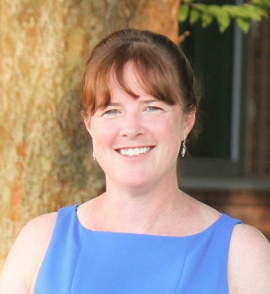

Colleen Morris
Position: Teacher
Local Association: HCEA(Howard)

I am interested in our National Association doing more for our local members. If elected to attend the NEA RA, I will vote for local priorities and new business items that support our students and staff. Thank you for your consideration and vote for NEA RA delegate.
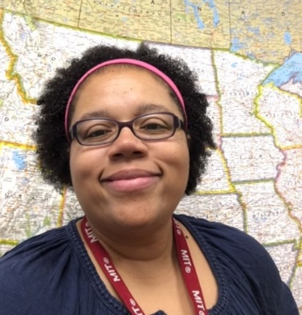

Jessica Nichols
Position: Teacher
Local Association: HCEA(Howard)

Hi! I would love the opportunity to represent you at the 2020 NEA Representative Assembly! I have served as a building rep in 3 counties. I currently serve you on the NEA Resolutions Committee and HCEA Board of Directors. I also represented you at the Boston and Houston Assemblies. I would love to represent you again!

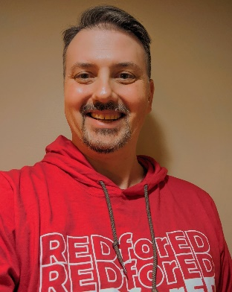

Jamie Parrish
Position: Teacher
Local Association: HCEA(Howard)

I am a member of my local Board of Directors, I have served as a delegate to the MSEA RA for the last two years and I was a Delegate to the NEA RA last year in Houston. I would love the opportunity to represent Maryland and my local association again this summer in Atlanta.

Lisa Pellegrino
Position: Teacher
Local Association: HCEA(Howard)

As a six-year teacher who changed careers, I have been working hard to learn and advocate on behalf of educators and students. I am a Building Representative who has attended multiple MSEA Assemblies, as well as two NEA Assemblies. Please support my intention to continue to learn and work for you! Lisa Pellegrino

Leah Ricciuti
Position: ESP
Local Association: SAAAAC

Having been a SAAAAC member since 2010, currently SAAAAC Treasurer and Central Office building co-representative. Last year serving on the committee to elect the First Annual ESP of the Year. I am involved with NEA Community Advocacy & Partnership Engagement (CAPE), going to the March 2019 ESP Conference in Las Vegas as a session presenter.

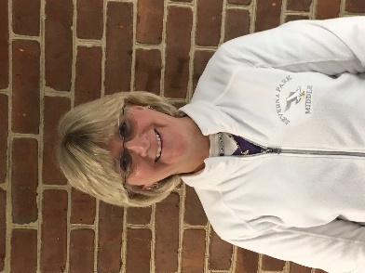

Debbie Schaefer
Position: ESP
Local Association: SAAAAC

I will advocate for all Education Support Professionals and Teachers.

Benjamin Schmitt
Position: Teacher
Local Association: HCEA(Howard)

I look forward to advocating and representing everyone as a delegate, while relying on my experience as an active union member, related arts teacher, husband to a classroom teacher, and parent to two school-aged children. Thank you so much for your vote!

Mary Stein
Position: ESP
Local Association: HCEA(Howard)

I have served as a representative and on the BOD of HCEA. I was also Maryland’s ESP of the year in 2017. I would like to continue to represent all of you at the NEA assembly.

Brittney Ware
Position: ESP
Local Association: HCEA(Howard)

Shante Young
Position: Teacher
Local Association: HCEA(Howard)

