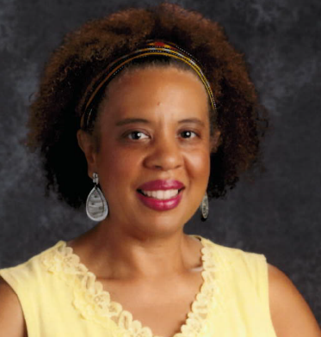

Linda Brown
Position: ESP
Local Association: ESPBC

I would like to attend to have my voice and opinions heard in order to best represent my members and to help make a difference where it matters.

Dorothy Chapman
Position: Teacher
Local Association: TABCO

I have been in Baltimore County Schools for twenty one years and seven years in New York City Schools. I have been a Tabco and a MSEA delegate. I am even more ready to speak up, stand up and step up for all in education especially our students.

Gregory Collins
Position: Teacher
Local Association: TABCO

I've been teaching in Baltimore Co for 26 years, currently working with Special needs students as a transition facilitator. I have been a member of TABCO for my entire teaching career and have been a delegate at the MSEA convention for 11 years.

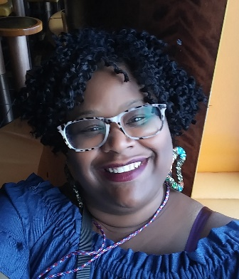

Pam Gaddy
Position: Teacher
Local Association: TABCO

Through the experiences, exposures and networking of attending the NEA-RA, I've had the opportunity to grow as an advocate. I've been able to utilize resources that empowers members of my building and recruit new members that will ultimately ensure the life span of our career and support our students. Please allow me to continue.

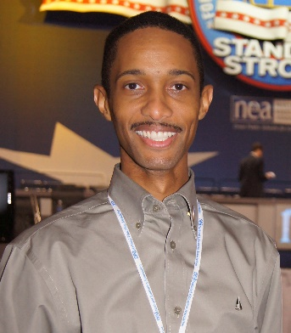

James Henderson
Position: ESP
Local Association: ESPBC

As an independent thinker, team player and staunch advocate of education, I will continue to work to enhance our profession and member’s rights to better serve our students. I proudly represent MSEA on the NEA Resolutions IEC (Internal Editing Committee) and respectfully request your support to re-elect me, James Henderson, to the 2020 RA.

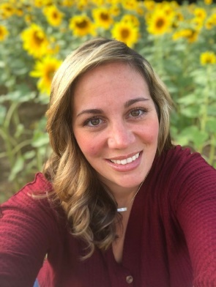

Lauryn Krauch
Position: Teacher
Local Association: TABCO

As a member of the TABCO union I am an advocate for students and educators. I have attended the 2017-2018 NEA R.A. and the 2017-2019 MSEA Conventions. These events allow us to unite our voices and have a greater impact for the students and educators. We need to speak up, speak out, and be heard!

Christina McLaughlin
Position: ESP
Local Association: ESPBC

As a 5th year ESPBC member and a devoted leader in the union I have a huge passion for education and funding for our students. I have attended the MSEA Convention as a delegate for the past two years. This past July I had the opportunity to attend my 1st NEA Convention as a delegate.

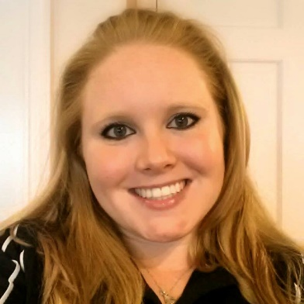

Kristel Rabideau
Position: Teacher
Local Association: TABCO

As an early career educator, teaching Spanish at a Title 1 middle school, it is important that I advocate for fellow educators and address the serious challenges facing our students in public schools across the state.

Lisa Williams
Position: ESP
Local Association: ESPBC

I am committed to serving our members and building a much stronger relationship with educators and fight for their rights. Having a voice for collective bargaining process, assisting our members towards improving the lives and workplace across our state and fostering solidarity among all of our workers.

