Deidra Baker
Position: Teacher
Local Association: EACC

My name is Deidra Baker. I am a resident of Southern Maryland. I am twenty years strong in education. Knowledge is power and funding moves the pendulum. As a local EACC board member I believe with unity, the union as an unbreakable cord will continue to make a difference in all lives. We rise together.

Jacob Bauer Zebley
Position: Teacher
Local Association: CCCTA

I hope to continue to serve my fellow educators as a delegate to the NEA Representative Assembly. My previous experience includes: NEA Director for Maryland, NEA Legislative Committee, LGBTQ+ NEA Board of Directors Caucus Chair, MSEA Board of Directors, Cecil County Classroom Teachers' Association Vice President, 2015 Cecil County Teacher of the Year.

Leigh Bondrole
Position: Teacher
Local Association: HCEA(Harford)

I currently serve as a local director for Harford County and have served in that capacity for both this district and my prior district in Arizona for over 10 years. I bring my experience as a veteran educator of 20 years and would be honored to serve Maryland as an NEA RA delegate.

Melissa Carpenter
Position: Teacher
Local Association: EACC

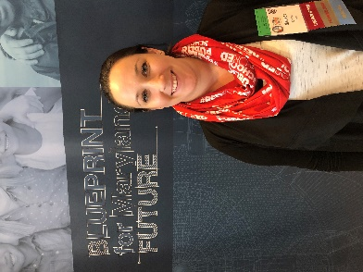

Melissa Coyne
Position: Teacher
Local Association: CCCTA

Make our voices heard! I feel very strongly in using my voice to start a movement. Teachers HAVE to advocate for themselves and being a delegate is the best way to do that. I stand up for the needs of the profession as a whole as well as the needs of my local and school.

Michael Curry
Position: Teacher
Local Association: HCEA(Harford)

I have been a proud member of MSEA since becoming a teacher. I have served on multiple committees, the Board of Directors, and Vice-President. I have worked locally, statewide, and nationally on CTE issues including passing 3 NBIs. I wish to proudly represent Maryland and continue my work with the national CTE Caucus.

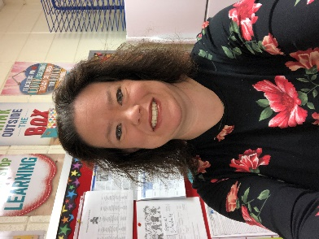

Traci Davis
Position: Teacher
Local Association: EACC

I would love to provide my voice to help my fellow members on education business that matters. I have gone and have represented my local and state as a delegate for the past few years. I stand up for what I believe in for the sake of education, for early childhood, and for my students.

Gorgette Green-Hodnett
Position: Teacher
Local Association: EACC

I am an Instructional Resource Teacher at Matthew Henson MS, having 20+ years of extensive experience in curriculum and instruction, teacher leadership and professional learning. As a mathematics educator, instruction must be relevant and accessible to all. The teacher shortage is REAL; what will we do when we know quality teachers are developed over time.

Dwayne Hancock
Position: ESP
Local Association: EASMC

I am a proud ESP. I understand the important role each of us play in educating young people, and how important it is that our MSEA members are represented with respect and integrity. I was honored to be your NEA delegate last year and hope to return to office for this upcoming year.

Sean Heyl
Position: Teacher
Local Association: EACC

Would love to continue my work representing a small county in Maryland on the national level. Previous experience at MSEA and NEA conventions. I would love to do more to promote student and teacher mental health in this era.

Brenda Hinton
Position: Teacher
Local Association: HCEA(Harford)

I currently serve as a local board of director for Harford County, and have served in this capacity as well as other district unions in New Jersey, Oklahoma, and West Germany. I bring my experience as a veteran educator of 38 years and would be honored to serve as a Maryland delegate for the NEA RA.

Lori Hrinko
Position: Teacher
Local Association: CCCTA

I would be honored to advocate for all Maryland educators at the national level and to be able to use the skills I have gained as a past constitution, rules, and bylaws committee chair, and MSEA Board member by continuing to serve as a delegate to the upcoming NEA RA. Yes, I really like meetings!

Devon Jenkins
Position: Teacher
Local Association: KCTA

In my three years of being a teacher in Maryland, I have represented KCTA as the Treasurer for two years, and Association Rep for my building for all three years. With 7 years experience as an officer or AR while a student, ESP and Teacher member, I would be honored to serve my local.

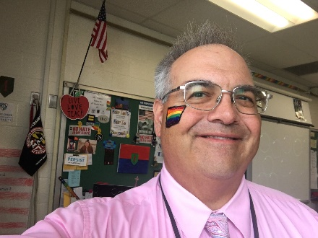

George Kasnic
Position: Teacher
Local Association: HCEA(Harford)

I am a 6th grade math teacher at Edgewood Middle School, serve on my association's Benefits Advisory Committee and Sick Leave Bank Committee. I sponsor my school's GSA. I was an MSEA delegate and am a former military officer.

Ashlee Langer
Position: Teacher
Local Association: KCTA

I have been a member of my local, Kent County Teachers Association for 9 years. I have been our President for the last 5 years. As the smallest teacher local, I would love to represent the voices of the Eastern Shore and smaller locals.

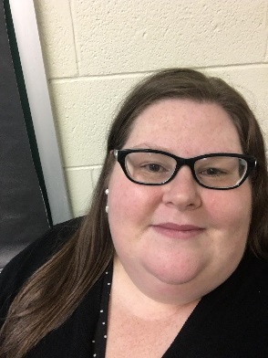

Jennifer Lanterman
Position: Teacher
Local Association: EASMC

I'm a special educator new to SMCPS and EASMC this year, I was an active member of PGCEA for 11 years during my 12 years in PGCPS. I thoroughly enjoy conducting union business and addressing, rallying for, and advocating for education causes leading to better working conditions for educators and learning environments for students.

Will Lewis
Position: Teacher
Local Association: EACC

Linda McLaughlin
Position: Teacher
Local Association: EACC

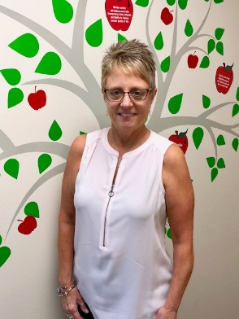

Jill Morris
Position: ESP
Local Association: EASMC

Kathy Myers
Position: Teacher
Local Association: EASMC
I have taught as a special education teacher in St. Mary’s County public schools since 1995. My goals are simple: be informed, be pro-active, and be present-for my kids and for my profession. My continued involvement as a NEA delegate is one step toward thee goals.

Karen Myers
Position: Teacher
Local Association: EASMC

Serving as a NEA Delegate helps me learn about educational issues across the United States. This also is a good way to make contacts with other educations and staff members. This helps us to see what great things Maryland is currently doing plus showing us where we can improve.

Rebecca Otte
Position: Teacher
Local Association: HCEA(Howard)

Jennifer Paul Bray
Position: Teacher
Local Association: HCEA(Harford)
Educator, this job reaches beyond the walls of the classroom, it reaches into the homes and community. We do so much more than teach our content, we support our students, families, and each other. This is why we need more support from our organizations and why I would like to be a delegate.

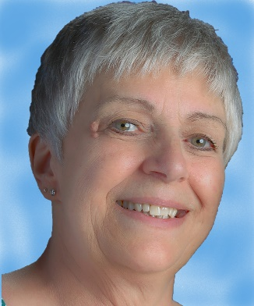

Cynthia Poper
Position: ESP
Local Association: HCESC

I am passionate about our Association and its role in our lives and the lives of our students. I am a dogged advocate for our profession, our students, our schools and improvements to our working lives. I am a diligent and dedicated worker that will do my best to represent you at our National RA.

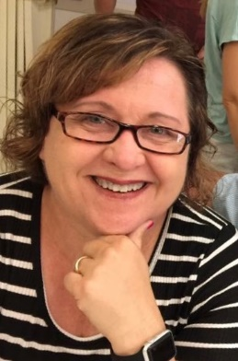

Denise Pratt
Position: Teacher
Local Association: EACC

I am a music educator in Charles County, Maryland. I am very involved in music curriculum writing and mentor music teachers in my school district. I am passionate about promoting the education of the whole student which should include education in the fine and performing arts.

Leslie Schroeck
Position: Teacher
Local Association: EACC

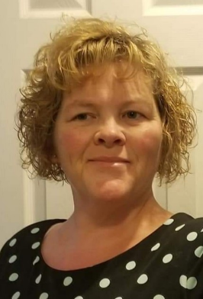

Linda Shackelford
Position: Teacher
Local Association: EACC

Dedicated. Responsible. And Enthusiastic. These are three words that describe me, and three reasons why you should vote for me for MSEA Delegate to the 2020 NEA RA. I want to continue to work at the National level and fight for our educators and students. So vote for “Shack”

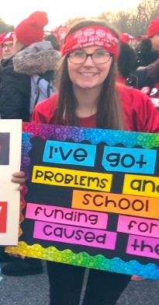

Chelsey Short
Position: Teacher
Local Association: EACC

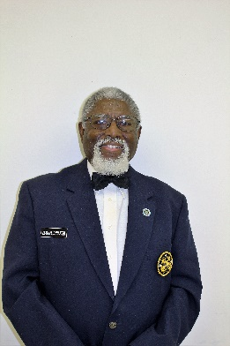

Peter Singleton
Position: ESP
Local Association: DE

I will represent you from the view of having 41 years of teaching, 6 years of substituting and now as an ESP, experience. 48 years total as a member. And having experience as a local building Rep, vice president, president and State Bylaw committee. Plus attending, as a delegate, to many MSEA and NEA conventions.

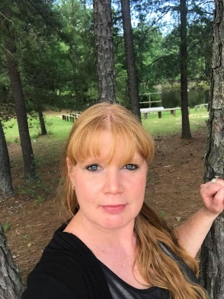

Christina Stephens
Position: Teacher
Local Association: EACC

As a Grassroots Member to the Arizona's RedforEd movement, to now the Maryland's MSEA, NEA, and County EACC Union, I am prepared to help represent the best interests of my fellow educators and students at all costs. I have been a Counselor in the school for 7-8 years and know there's no "I" in team.

Robert Tucker
Position: Teacher
Local Association: HCEA(Harford)

Hi everyone! Would love your votes for work on walking out policy statements. Movement on policy agendas re: equity, gender, arts education, ESP living wage and ECE concerns. Willing to dress in full white-face mime for PAC if elected. HCEA Director, Membership committee, ECE sub-committee, MSEA Membership Organizing Committee Co-chair. Happy voting!
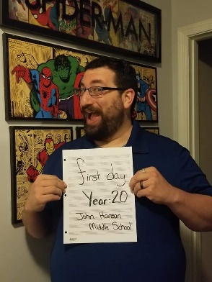

Peter Ullmann
Position: Teacher
Local Association: EACC

I have been a local representative for the past 7 years, working to ensure that our members receive the best resources, protection, and representation possible. I am an active Executive Board member who regularly attends budget hearings, school board meetings, and polling locations to advocate for the needs of our teachers and students.

Andrea Weedn-Hughes
Position: Teacher
Local Association: HCEA(Harford)

I am a second year teacher at Aberdeen Middle School. I was a SPARKS participant this year at the MSEA convention, and the experience definitely sparked my interest in being more involved. I have signed up to be a building representative in my school and would love the opportunity to go to the NEA RA.

