Jaime Bohannon
Position: Teacher
Local Association: MCEA

I teach Pre-K students who are deaf/hard of hearing. I have served as delegate from my local to MSEA convention (2016, 2017, 2018, 2019) and NEA RA (2017, 2018). I currently serve on board of directors for MCEA. Member of multiple NEA caucuses. Looking for the opportunity to serve MSEA at the national level!

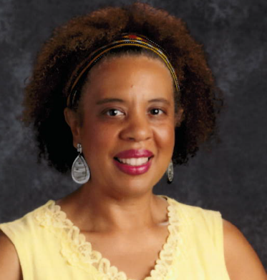

Laura Brown
Position: Teacher
Local Association: MCEA

Representation is extremely important to me. We fought and won one position on the State Board of Education, but hundreds of our members who work with and support students daily were ineligible to vote because they have advanced certification, but not a teaching certificate.
I am going to fight to change this for our members.

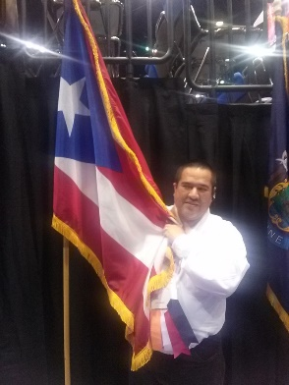

Jose Casiano
Position: Teacher
Local Association: MCEA

Equity and Excellence in Education Certificate/ M.S. NEA Empowered Educators Conference in Denver 2014. Physical Education Teacher at Wheaton Woods ES (Title 1), NEA RA/ Orlando 2015, Boston 2017, Minn.2018, Houston 2019.MSEA RA/15,16,2017,18, 19 Teacher in Charge WWES. MCEA Building Rep., PAC Captain NEA/MSEA, Hispanic Caucus, BOND member since 2017.

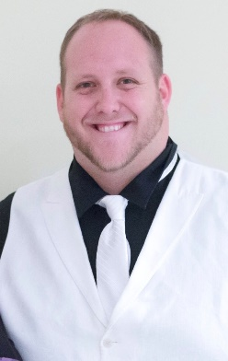

Adam Gawlinski
Position: Teacher
Local Association: MCEA

I have served as a delegate to the NEA convention 3 times. I enjoy the NBI process and understanding what business helps move our association forward. At convention I thoroughly read through all NBIs to make an informed vote on the issues. I hope you will elect me for this years NEA Convention.
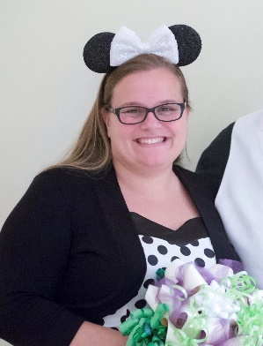

Stephanie Gawlinski
Position: Teacher
Local Association: MCEA

I have had the honor of serving as a delegate to the NEA convention 5 times. I have served on the PAC committee many times to raise money for public education. I currently serve in the MSEA PAC statewide committee. Vote for me so I can be your voice at the national level.

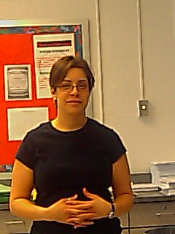

Annabella Letona
Position: Teacher
Local Association: MCEA

Teacher voices need to be heard! I am asking for your support to represent our members as an MSEA Delegate for MCPS. As educators, we must be the leaders of our profession. We must define what good teaching looks like. Together we can ensure we meet the needs of our students.

Kelli Petty
Position: Teacher
Local Association: MCEA

I have been a delegate for several years. I'm a former teacher and have been a school counselor for 10 years. I understand the social emotional needs of students and the academic demands in the classroom. With that said, I look forward to raising the voice of educators and students at the RA this year.

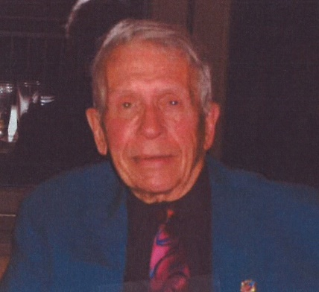

Jim Politis
Position: Substitute
Local Association: MCEA

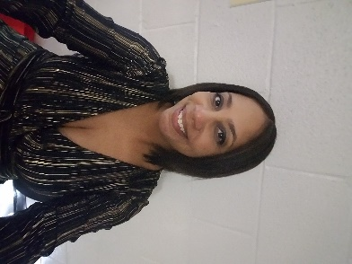

Brandy Reazer
Position: Teacher
Local Association: MCEA

I currently serve on MSEA and NEA Resolutions. I am an active member of MCEA as a building rep, EFR, and Creditials and Elections committee.

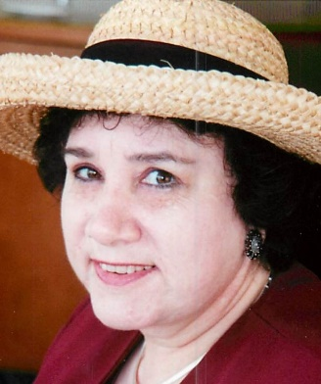

Jane Stern
Position: Substitute
Local Association: MCEA

My 55 years as a full time, then substitute, teacher and 52 consecutive years as an Active MSEA and NEA-RA delegate bespeak my dedication to all member concerns.
Local president, (1983- 1985), local Board of Directors (1971-1975, 1983- 1991), MSEA board member, treasurer, vice-president and president for a total of 30 years of board service.
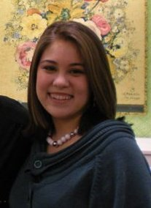

Danillya Wilson
Position: Teacher
Local Association: MCEA

I would love to represent my state as a delegate at the 2020 NEA RA. I believe in working hard for our kids and the schools they deserve. There is so much passion at the national level and I can't wait to be a part of something so amazing. Please help me help our kids.

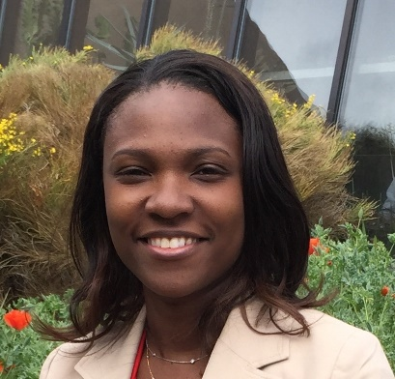

Anzer Woodward
Position: Teacher
Local Association: MCEA

I am committed to building the strength and power of the educator's voice. To be heard we must be present and have members who will stand up and speak out. As a delegate, I will represent you and speak and be active on the behalf of Maryland educators.

